**HW3:Solutions**

**SDGB 7844: Statistical Methods and Computation I**

**Minxia Ji**

**Question 1**

**Based on my simulation,**

**m2:2**

**N.lp:5000**

**Question 2**

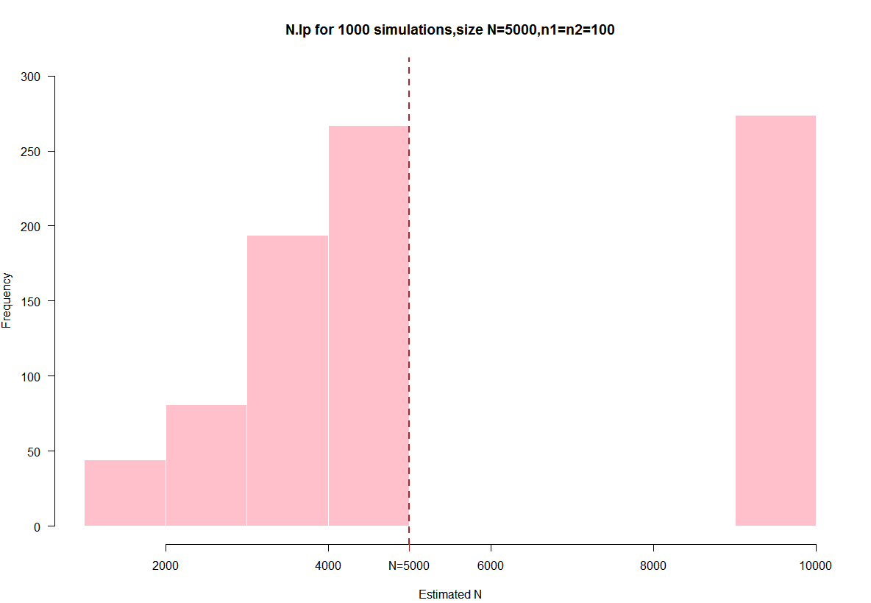

**Question 3**

14% of the estimated population values in question 2 are infinite.

The reason why infinite numbers appear is that the second capture may contains no fish like that captured in first capture.Thus, m2 is equal to zero, there comes infinite number.

**Question 4**

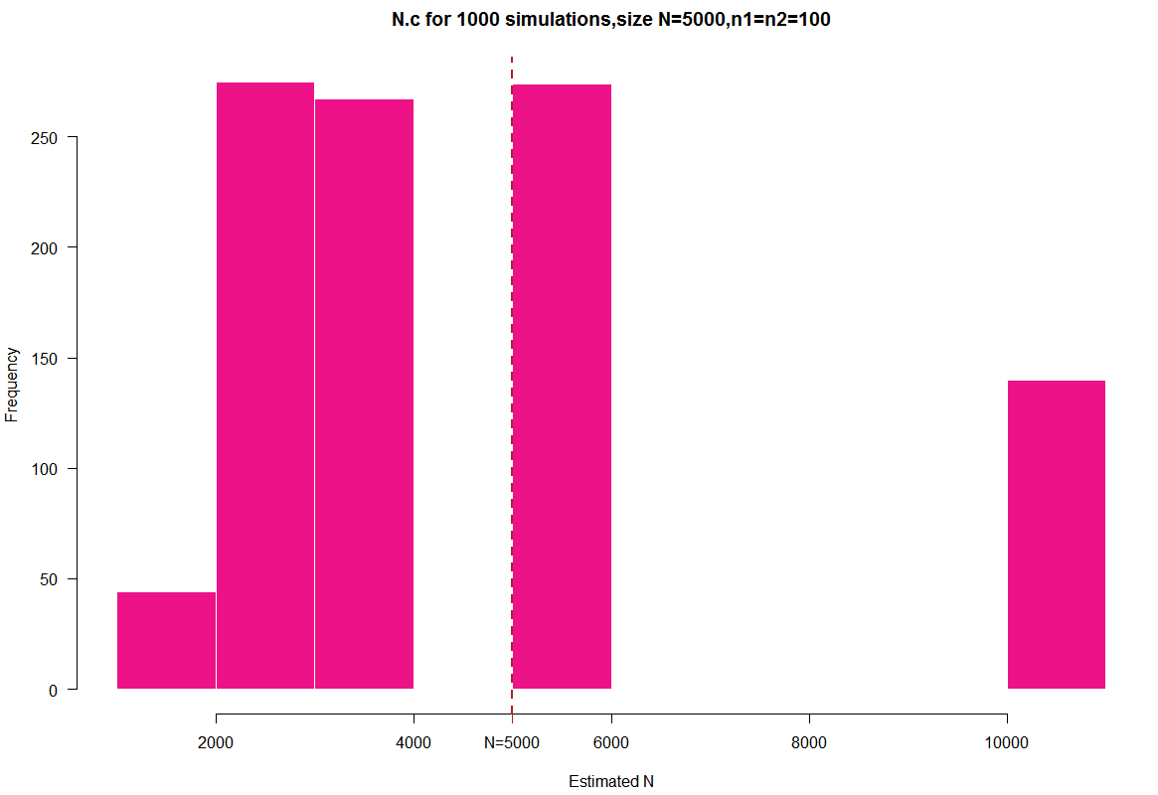

**Question 5**

Based on the results of my simulation, the bias of the Lincoln-Peterson is infinite.The bias of Chapman estimators is -536.419.

when n1,n2=100, none of the estimators is unbiased.

**Question 6**

The Chapman estimator is better than the Lincoln-Peterson estimator.

The Chapman estimator will not be infinite even if m2=0.

Compared to the Lincoln-Peterson estimator, the Chapman estimator is much closer to true population size.

**Question 7**

Under the circumstance that the number of simulation runs per sample size is 1000, when the sample sizes became larger, the estimates are better .

In the *bias and n* plot, the bias became larger rapidly at the very beginning. When sample sizes get larger, bias gets closer to zero.

In the *variance and n* plot, the variance is small at the beginning. However, when sample sizes get larger, variance experiences dramatic increase at first and then drop gradually to get closer to zero when sample size keep increasing.

Therefore, we can get better result estimates using larger sample sizes.

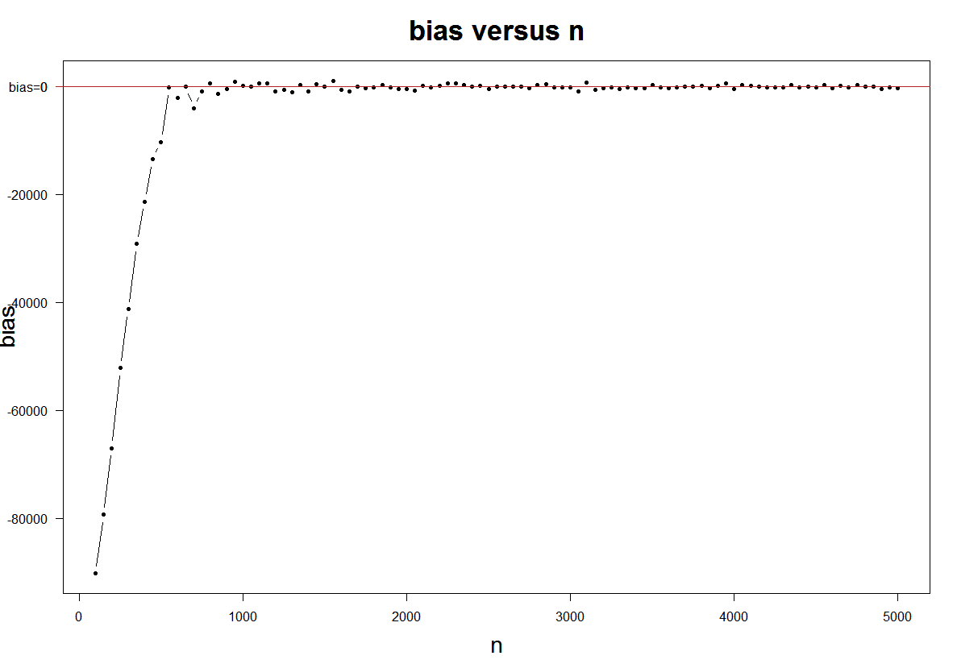

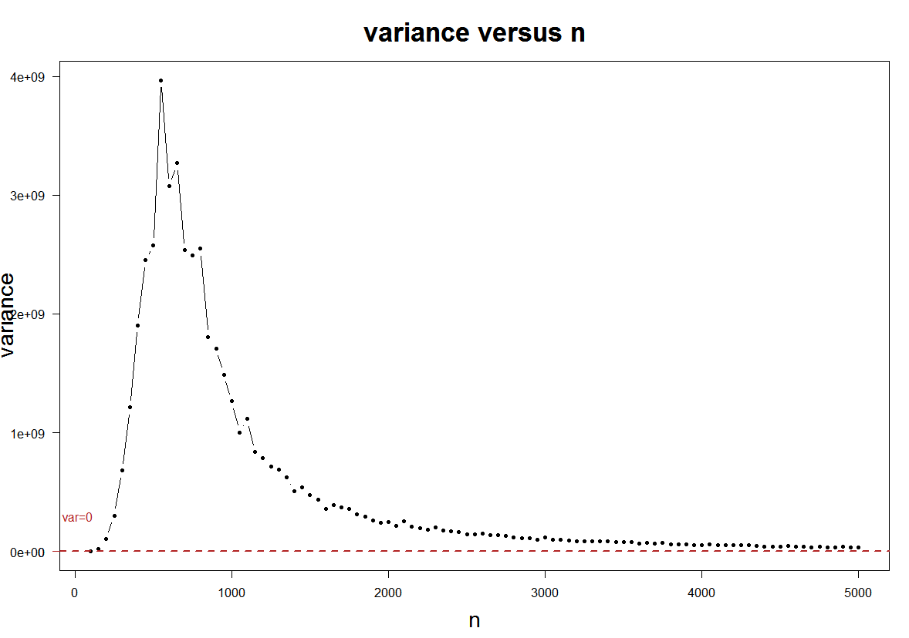

**Question 8**

N.c could be a consistent estimator.

To simulate it, I use the same function in Question7.Increase sample size to a sequence from 100 to 10,000 by 50, simulation run as 1 and N as 100000.The bias and n plot shows that as sample size becomes larger, the bias gets closer to zero. Therefore Chapman estimator could be a consistent estimator.

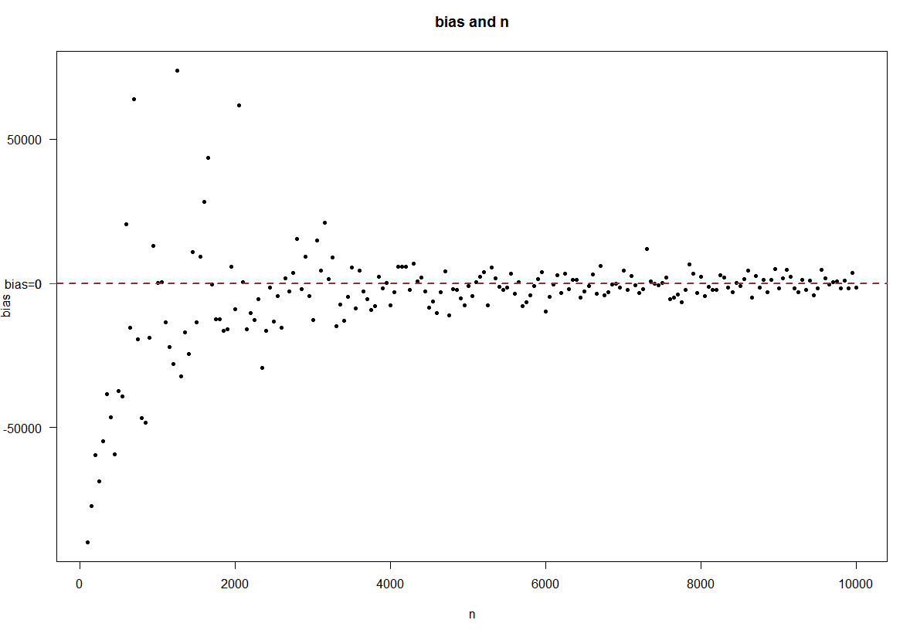

**Question 9**

1. each individual is independently captured,

(b) each individual is equally likely to be captured,

(c) there are no births, deaths, immigration, or emigration of individuals (i.e., a closed population)

They are unrealistic because:

For(a), for example, if we want to capture fish, they might not be captured independently. Once a fish was captured, it could release some sort of signal or warning to tell other fish there’s a danger.

For(b),each individual is not likely to be captured equally.In real world, individuals have different size, strength and other features.We can not say that for example, catch a big fish would take the same efforts as catch a small fish.

For(c), it is unavoidable to face the births, deaths, immigration or emigration of individuals.Like the action we take to capture fishes could cause some fishes to die.